Exposure Java | Exercises 05.12 | Date:
Name: |  | Period:

Part 1 - Truth Tables
In each of the following exercises use truth tables to determine if the given Boolean expressions are equivalent or not equivalent.
You will NOT receive ANY credit without the Truth Tables!


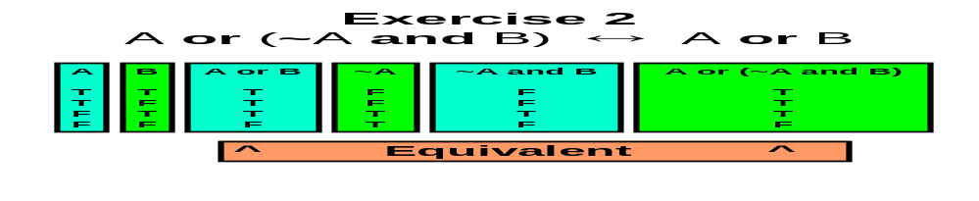
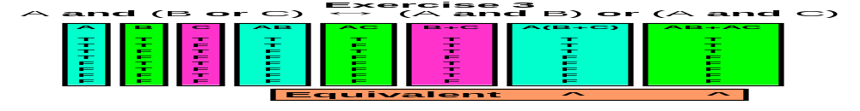
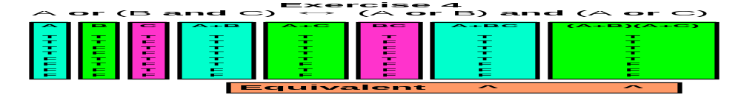
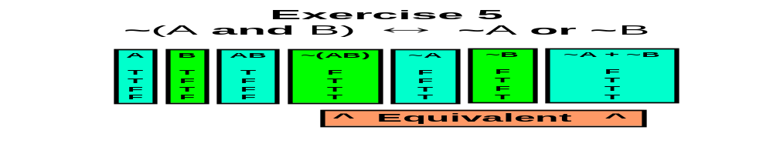
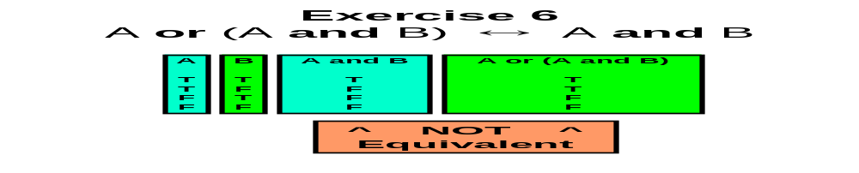
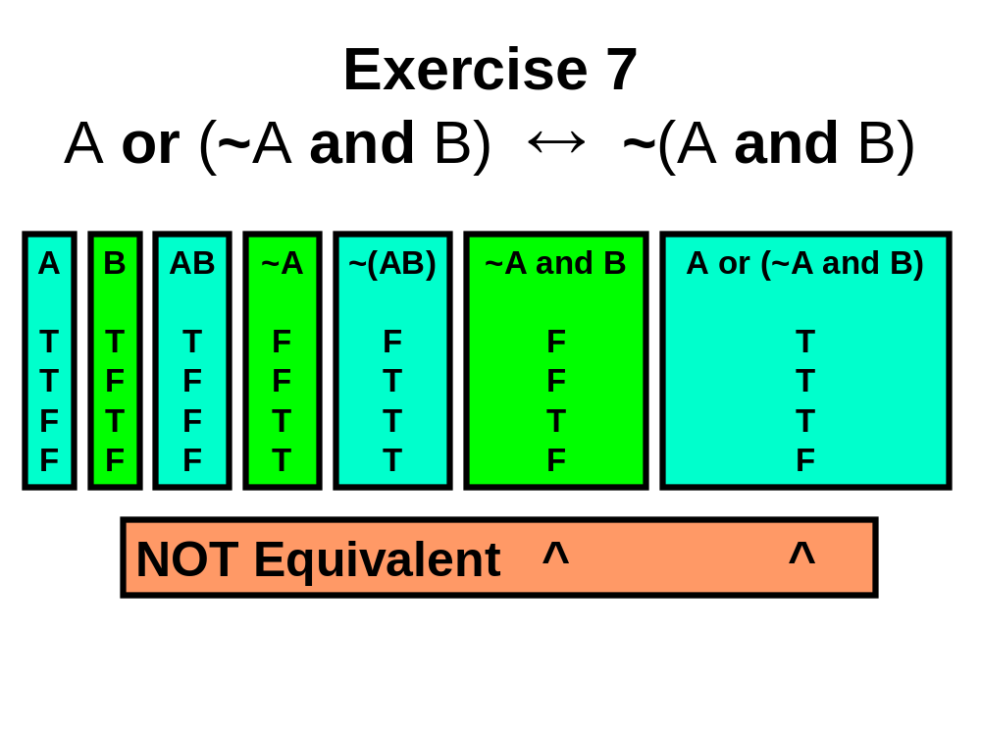
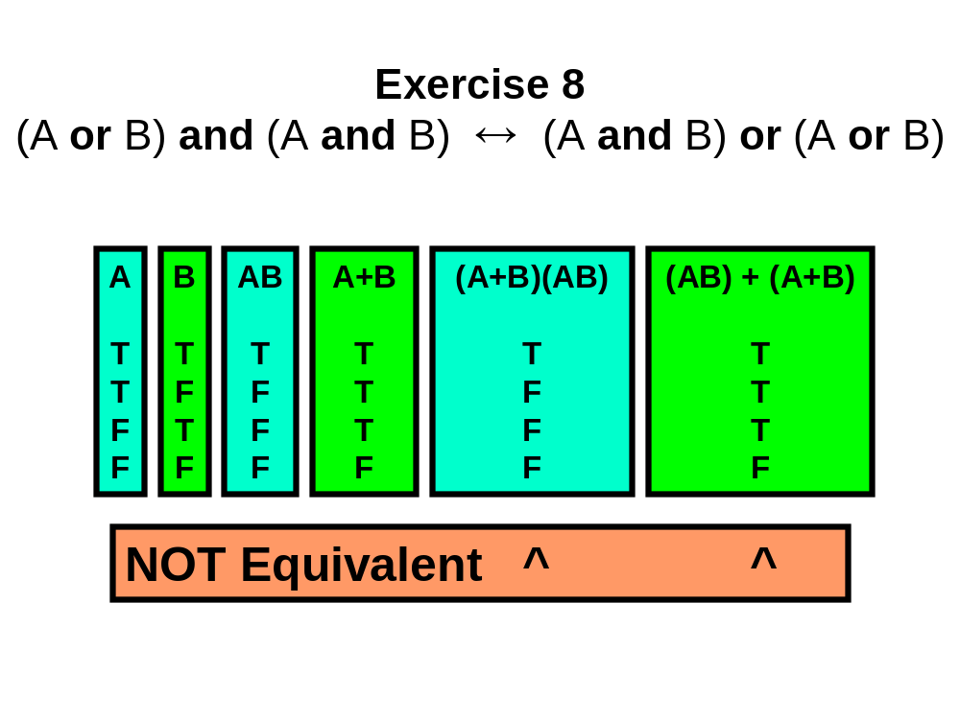

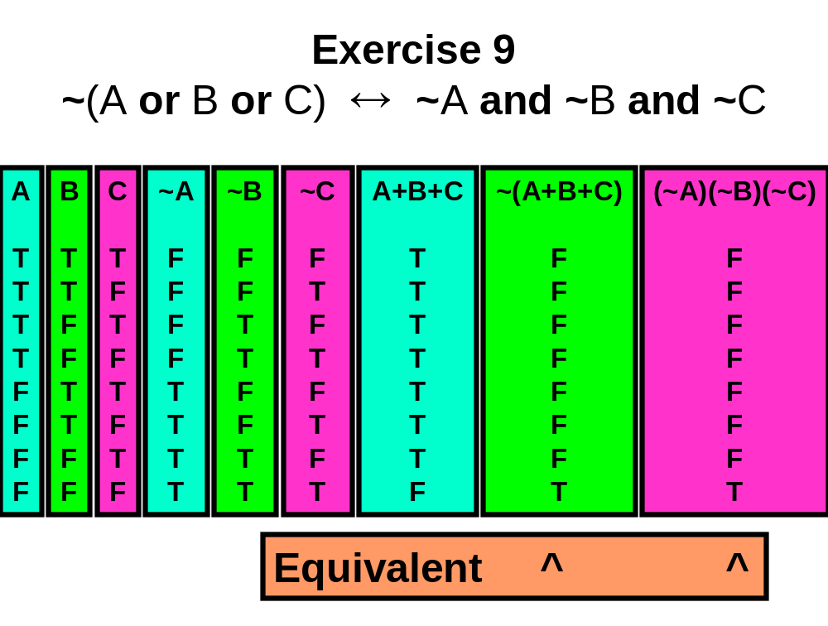
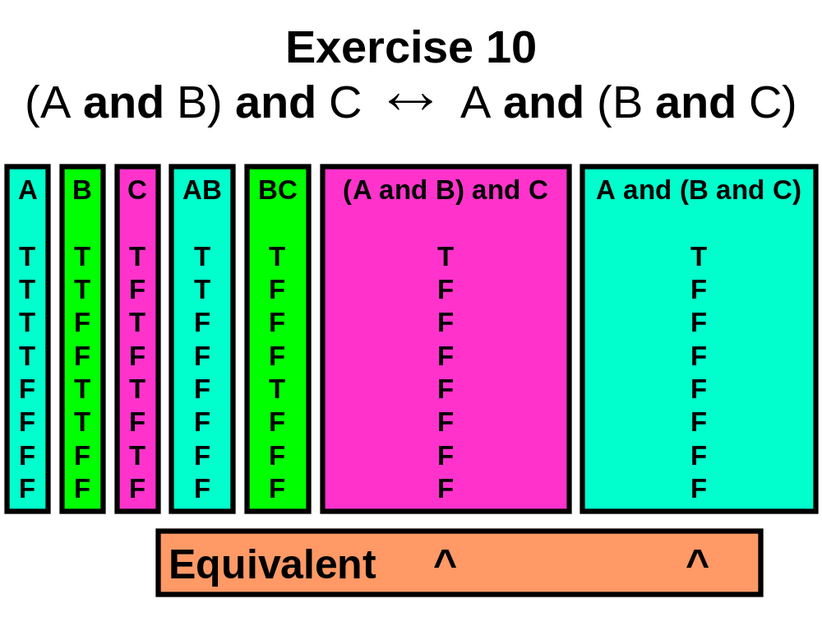

Part 2 - Boolean Logic Exercises
Circle the “Best” answer for each of these Multiple Choice questions.

11. The Boolean expression  A < B  is equivalent to which of the following expressions?  (A) not(A < B)  (B) not(B < A)  (C) not(A >= B)  (D) A >= B  (E) B <= A | 12. The Boolean expression  (A and B) or A  is true  (A) only when A is true.  (B) only when B is true.  (C) whenever either A is true or B is true.  (D) only whenever both A is true and B is true.  (E) for all values of A and B.
13. The Boolean expression  (A and B) or (A and B)  is true  (A) only when A is true.  (B) only when B is true.  (C) whenever either A is true or B is true.  (D) only whenever both A is true and B is true.  (E) for all values of A and B. | 14. The Boolean expression  not(A and not B)  is equivalent to which of the following expressions?  (A) A != B  (B) not A or B  (C) not A and not B  (D) not A or not B  (E) not A and B
15. The Boolean expression  not(A or B or C)  is equivalent to which of the following expressions?  (A) A != B != C  (B) A and B and C  (C) A or B or C  (D) not A or not B or not C  (E) not A and not B and not C | 16. The Boolean expression  (A and B) or not(A and B)  evaluates to  (A) true in all cases.  (B) false in all cases.  (C) true whenever only A is true or only B is true.  (D) true whenever both A is true and B is true.  (E) false only when both A is false and B is false.

17. The Boolean expression  not((A >= B) or (C < D))  is equivalent to which of the following expressions?  (A) (A <= B) or (C > D)  (B) (A <= B) and (C > D)  (C) (A < B) or (C > D)  (D) (A < B) or (C >= D)  (E) (A < B) and (C >= D) | 18. The Boolean expression  (A and B) and (not A or not B)  evaluates to  (A) true in all cases.  (B) false in all cases.  (C) true only whenever both A is true and B is true.  (D) false only whenever both A is false and B is false.  (E) true only whenever A is true or B is true.
19. The Boolean expression  (not A and B) or (A and not B)  evaluates to  (A) true in all cases.  (B) false in all cases.  (C) true only whenever A is false and B is true.  (D) true only whenever both A and B are the same  (E) true only whenever both A and B are the different | 20. The Boolean expression  (A and B) or (not A and not B)  evaluates to  (A) true in all cases.  (B) false in all cases.  (C) true only whenever A is false and B is true.  (D) true only whenever both A and B are the same  (E) true only whenever both A and B are the different

